Criando o resource de Cupom em Service

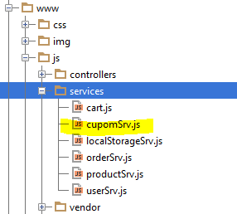

**angular**.module(**'starter.services'**).**factory**(**'Cupom'**, [**'$resource'**, **'appDevConfig'**, **function** ($resource, appDevConfig) {  
 **return** $resource(appDevConfig.**baseUrl** + **'api/cupom/:code'**, {**code**:**'@code'**}, {  
 **query**: {  
 **isArray**: **false** }  
 });  
}]);

Importar na Index

<**script src="js/services/cupomSrv.js"**></**script**>

Testar no controller checkoutCtrl.js – ClientCheckoutCtrl

**angular**.module(**'starter.controllers'**)  
 .**controller**(**'ClientCheckoutCtrl'**,[  
 **'$scope'**, **'$state'**, **'$cart'**, **'Order'**, **'$ionicLoading'**, **'$ionicPopup'**, **'Cupom'**,  
 **function** ($scope, $state, $cart, Order, $ionicLoading, $ionicPopup, Cupom) {  
 Cupom.get({**code**: 7491}, **function**(data) {  
 ***console***.log(data);  
 }, **function** (error) {  
 ***console***.log(error);  
 });